Installing Revit Structure 2011

To Install the Deployment

- Navigate to I:\Your Office\Software\SE (or Drafting if on the West Coast)\Autodesk REVIT\

- Open either “64bit” or “32bit” depending on your operating system.

- Open “Autodesk Revit 2011”

- Run “Revit Structure 2011 – x64” or “Revit Structure 2011 – x32” (depending on operating system).

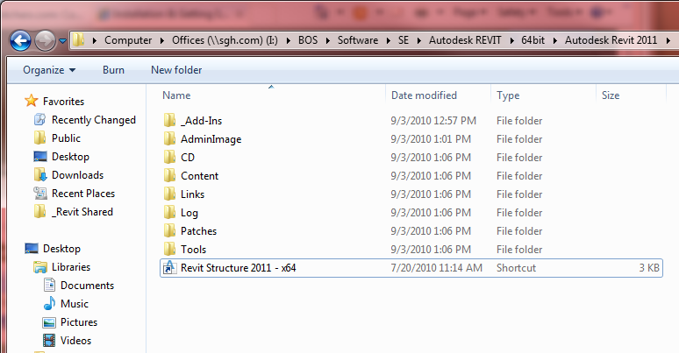

- Select “Next” until the install finishes and then select “Finish.”

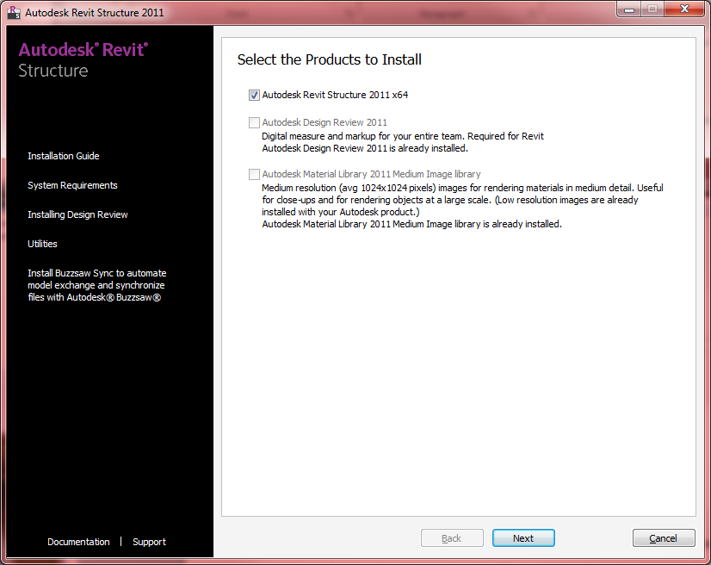

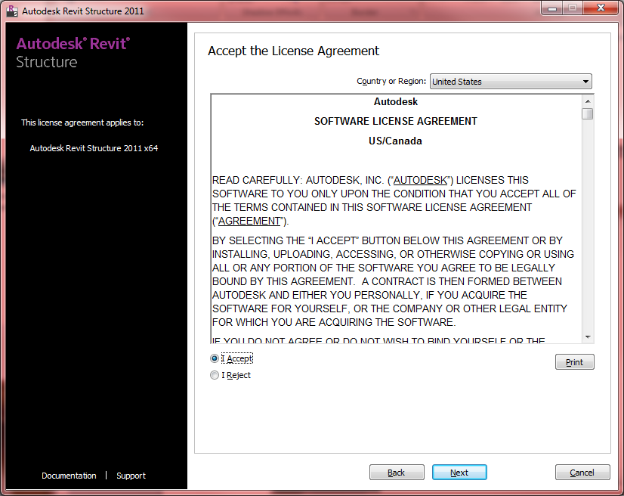

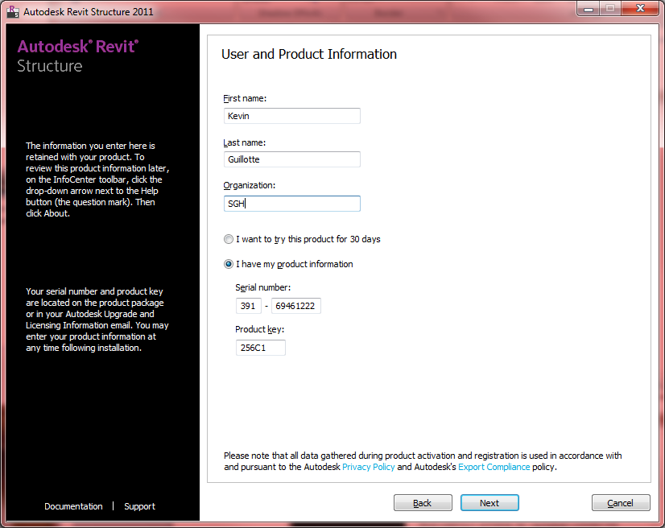

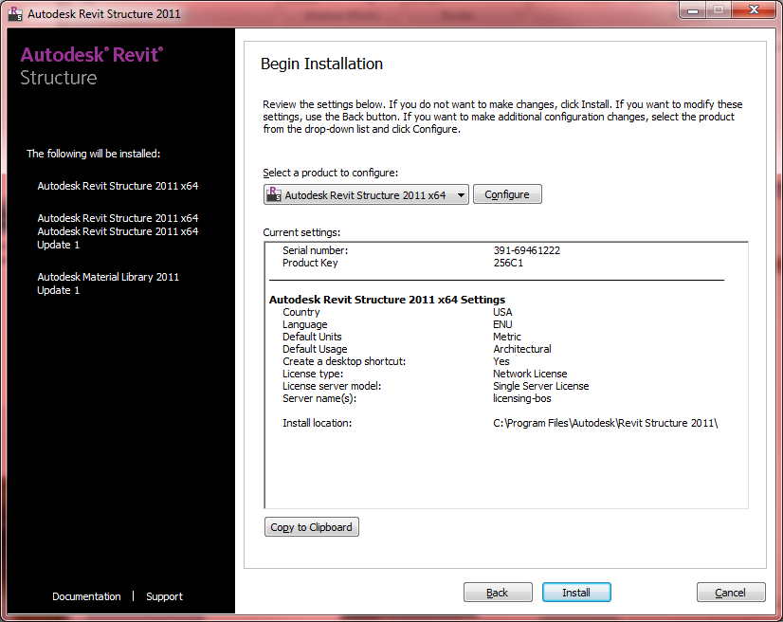

Once the Deployment is Installed

- Download the file “KeyboardShortcuts_2010” file from SGHNet

- Open Revit Structure 2011

- Open the Application Menu (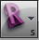) and choose “Options”

- On the User Interface tab choose “Customize”

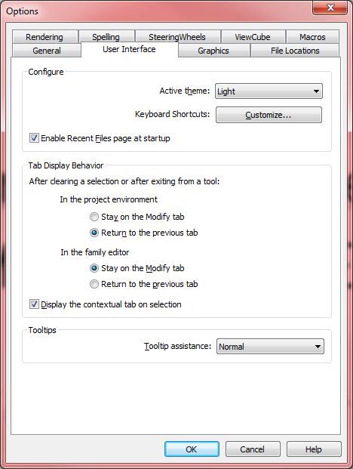

- On the bottom of the “Keyboard Shortcuts” dialog chose “Import”

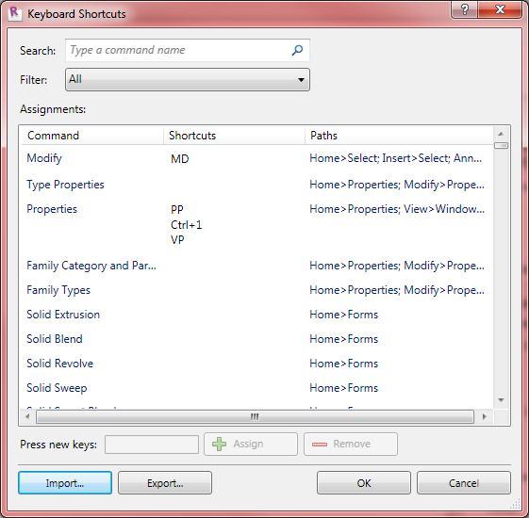

- Navigate to and choose the shortcuts file downloaded in step 1.

If Revit 2011 is Already Installed

If Revit 2011 has already been installed on your computer you may need to install service packs.

To check if your version is up to date

- Click the small arrow next to the help menu (small question mark in the top right corner)

- Choose “About”

- In the top right corner of the About Autodesk Revit Structure 2011 is the build.

- The current build is “20100903_2115 Web Update 2 Service Pack”

- You can also click on the small satellite dish icon in the same menu as the help menu. At the bottom of the menu it will say whether your version is up to date.

If you need to install a service pack

- Close Revit Structure 2011

- Navigate to I:\Your Office\Software\SE (or Drafting if on the West Coast)\Autodesk REVIT\64bit (or 32bit)\Autodesk Revit 2011\Patches

  - In the 64bit version of that folder there is a PDF outlining all the updates that were made in the service pack.

- Run the application in that folder.

- It will install silently and when it’s done you can run Revit.

